* 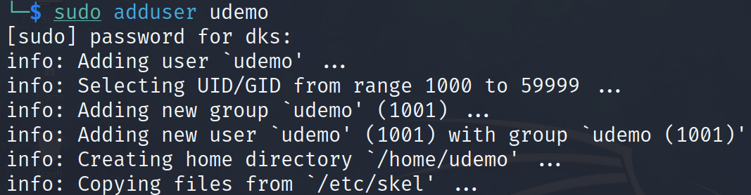Display how to add a new user ‘demouser’
* 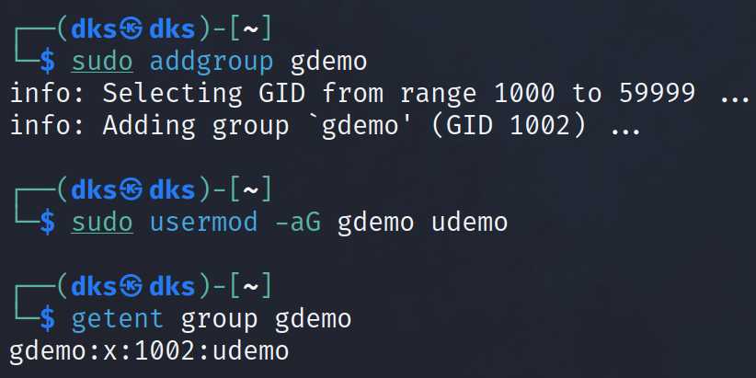Show how to add the above user in a group
* 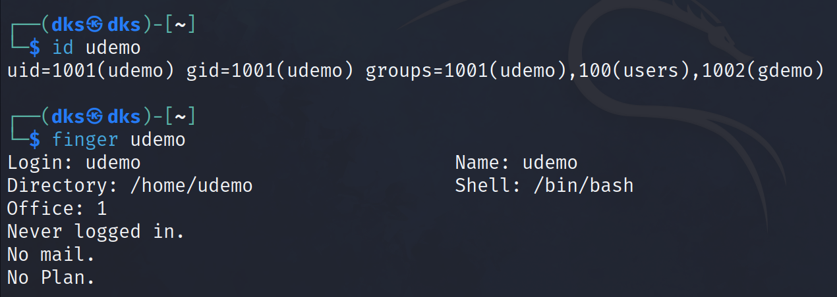Show where we can find user details
* Create a readme.txt using Vi editor.

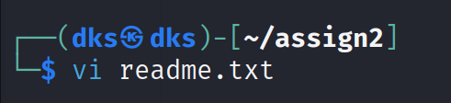

* By using numerical values, give rw-rwx ---- to newly created readme.txt

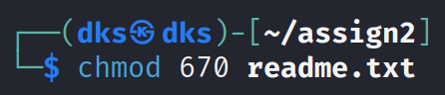

* Display the permission in the /etc file

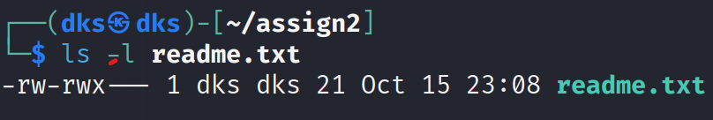

* 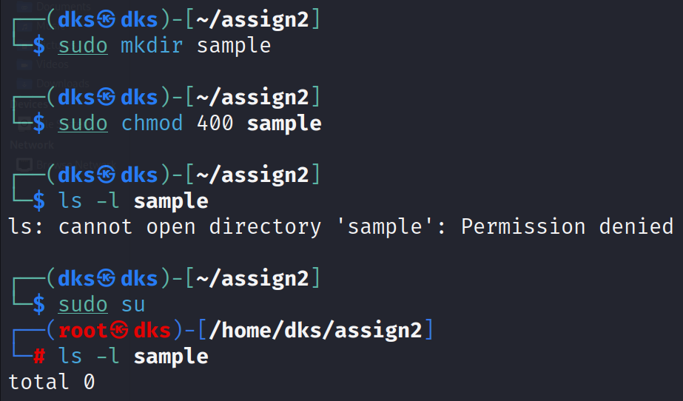Create a new directory ‘sample’. Set its permissions such that only the root user can read.
* Change the ownership of readme.txt to root and display

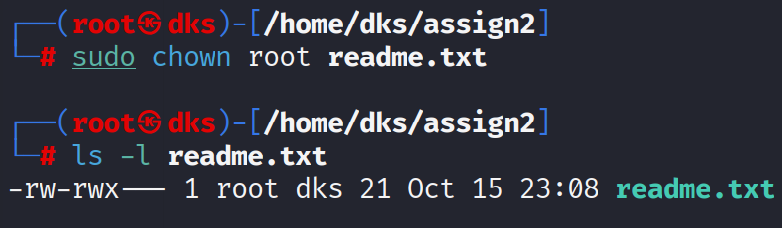

* 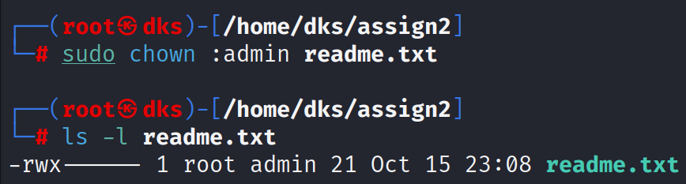Change the group of the readme.txt to the ‘admin’ group
* Add any user to a newly created group and display

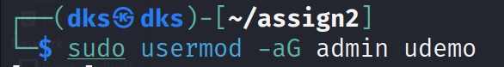

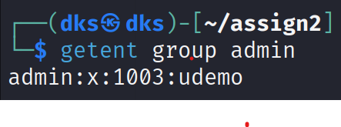

* Display how to delete a user

